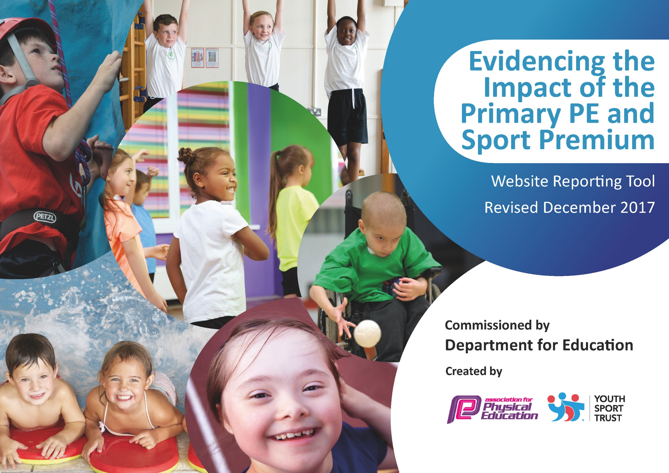

Schools must use the funding to make additional and sustainable improvements to the quality of PE and sport they offer. This means that you should use the Primary PE and Sport Premium to:

- develop or add to the PE and sport activities that your school already offers
- build capacity and capability within the school to ensure that improvements made now will benefit pupils joining the school in future years

Please visit gov.uk for the revised DfE guidance including the 5 key indicators across which schools should demonstrate an improvement. This document will help you to review your provision and to report your spend. DfE encourages schools to use this template as an effective way of meeting the reporting requirements of the Primary PE and Sport Premium.

We recommend you start by reflecting on the impact of current provision and reviewing the previous spend.
Under the Ofsted Schools Inspection Framework, inspectors will assess how effectively leaders use
the Primary PE and Sport Premium and measure its impact on outcomes for pupils, and how effectively governors hold them to account
for this.

Schools are required to publish details of how they spend this funding as well as on the impact it has on pupils’ PE
and sport participation and attainment.
We recommend regularly updating the table and
publishing it on your website as evidence
of your ongoing review into how you are using the money
to secure maximum, sustainable impact. To see an example of how to complete the table please click HERE.

Support for review and reflection - considering the 5 key indicators from DfE, what development needs are a priority for your setting and your students now and why? Use the space below to reflect on previous spend, identify current need and priorities for the future.

Key achievements to date: | Areas for further improvement and baseline evidence of need:
The renewed purchase of a whole school PE scheme has enabled staff to teach, well planned and well-resourced PE lessons. They have 6 Unit packs for each year group that come with medium term planning, short term lesson plans and video aids. The Real PE – Jasmine scheme also provides a home learning pack that we were able to use during the lock down, home schooling period. The purchase of this scheme also included one whole school training inset day and three PE Coordinator training days. The new scheme focusses around 6 learning cogs that are up to date and relevant in today’s culture and society; Personal Skills, Social Skills, Cognitive Skills, Creative Skills, Physical Skills and Health and Fitness. These units all work around improving the ‘whole child’ and they are based around different coordination, balance and agility techniques. We have also extended our Jasmine subscription so that we now receive Dance and Gymnastics Units for staff to teach. These follow the same 6 learning cogs and are used alongside the Real PE  Units.  KS1, KS2 and EYFS staff have received feedback from monitoring observations on a regular basis, linked to the new PE scheme.  PE teaching demonstrations provided by the PE Coordinator have been observed by KS1 and EYFS staff to embed best practice and increase staff knowledge.  Staff report increased confidence in teaching PE and feel comfortable using the new scheme confidently. The 2019 whole school CPD was enlightening and gave staff confidence to teach PE with a new, positive outlook.  PE lesson planning has been highlighted as exemplar in most cases, especially since the introduction of the new scheme.  Monitoring that scrutinizes lessons taught and evidence of pupil progression has been used to support staff and children with their teaching and learning. Video evidence has been recorded to show SLT and the PE subject leader what is taught during PE lessons and what children have learnt.  Pupil attendance and attainment has risen continuously from September 2018 enabling the school to meet national expectations in PE with highlighted children from each cohort exceeding the national expectation.  New Foundation Assessments used in PE by class teachers, NCSS and support staff to determine children’s PE attainment linked to National Standards.  High quality and varied extra-curricular activities and clubs led by the sports coordinator, the Sport and Wellbeing Apprentice, NCSS and other class teachers, allow access for all pupils to take up sport. High levels of participation are noted.  We offer a range of morning and after school sports clubs as well as lunch time sports leader clubs aimed at KS1 and EYFS.  These clubs allow for mass participation and later focus on team training for Scarborough Sports Association competitions.  Playground sports equipment has been purchased and maintained over a long period of time now, promoting exercise and physical activity through fun games.  The Daily Mile is ran by each class on a regular basis. Each class has a time slot on the playground or school field. In events of bad weather, children take part in GoNoodle Dance or Cosmic Kids Yoga.  We hold 2 inter school sports days at both Key Stages and at EYFS.  Sporting celebrations including Sport Relief, Olympian Visits and a School Sport Week have helped raise awareness in sport.  Yearly visits to an elite sporting event with other local Primary Schools.  Children have the opportunity to attend mass participation events in Athletics, Cross country and Multi Sport games.  Richardsons and British Cycling join together on a yearly basis to provide a Tour de Yorkshire cycling day for the whole school which has prviously led to British Cycling staff teaching upper KS2 children weekly cycle track skills lessons. We have since introduced balance bikes and scooters to EYFS and Year 1 to continue the TdY legacy and plan to hold inter class competitions in Summer 2022. After taking on board feedback from parents, we purchased whole school bike racks which has allowed us to invite children to travel to school on their bikes daily. This has been a popular initiative.  Success in local and county competitions has provided results against the extra-curricular activities. Local and Regional Hard Ball and Kwick Cricket Winners (boys and girls teams), Semi Finalists in the Yorkshire Kwick Cricket Competition, Medium School Football League winners, Netball Scarborough and District Competition winners, KS1 Athletics winners 3 out of 5 years. Scarborough Sports Team of the Year 2017 (cricket).  Our KS1 children have also participated in a newly formed, fun football tournament, this was successful in involving as many KS1 children to participate in extracurricular games and training before performing in the competition.  Mr Vasey received the Scarborough & District ‘Sports Teacher of the Year’ Award for his services to the Scarborough Schools Sports Association, running local and intra school competitions and training staff during the implementation of new sports curriculums. | Continue to provide PE lesson demonstrations to aid teacher confidence and knowledge in teaching Gym and Dance in EYFS, KS1, KS2.  Promote playtime activities with the new class sports bags and resources.  Link our foundation assessment criteria with the assessment criteria on the Real PE Scheme.  Use of the new class ipads to use when teaching Jasmine PE and when assessing, recording and promoting.

Meeting national curriculum requirements for swimming and water safety | Please complete all of the below*:
What percentage of your current Year 6 cohort swim competently, confidently and proficiently over a distance of at least 25 metres? | 75% - based on September 2022
What percentage of your current Year 6 cohort use a range of strokes effectively [for example, front crawl, backstroke and breaststroke]? | 75% - based on September 2022
What percentage of your current Year 6 cohort perform safe self-rescue in different water-based situations? | 100% - based on September 2022
Schools can choose to use the Primary PE and Sport Premium to provide additional provision for swimming but this must be for activity over and above the national curriculum requirements. Have you used it in this way? | Yes – providing KS1 and lower KS2 swimming lessons to increase water safety, being in a seaside town. Hit The Surf also completed.
*Schools may wish to provide this information in April, just before the publication deadline.

Action Plan and Budget Tracking
Capture your intended annual spend against the 5 key indicators. Clarify the success criteria and evidence of impact that you intend to measure to evaluate for students today and for the future.

Academic Year: 2022/23 | Total fund allocated: £17730  Total fund spent so far: £16299  Total fund left to spend £1431 | Date Updated: October 6th 2022
Key indicator 1: The engagement of all pupils in regular physical activity – Chief Medical Officer guidelines recommend that primary school children undertake at least 30 minutes of physical activity a day in school |  |  |  | Percentage of total allocation:
 |  |  |  | £14,379 = 81%
School focus with clarity on intended impact on pupils: | Actions to achieve: | Funding allocated: | Evidence and impact: | Sustainability and suggested next steps:
Deliver high quality physical education for all children. Highlight the fundamentals of exercise and healthy living from an early age. Use detailed planning to offer a wide range of physical activities across the curriculum. Differentiate activities to suit SEN and G&T children as well as different abilities within the class.  Classes to receive two PE lessons per week plus added lunch time and after school extra-curricular clubs. We aim to have all children participating in the curriculum lessons and as many as possible for mass participation in extra-curricular activities.  School Sport and Wellbeing Apprentice. Mr Sutherland works alongside staff in school as well as college tutors to gain qualifications for teaching sport and wellbeing in education. This apprenticeship allows the staff member to offer morning and afterschool sports clubs, assist teachers in classrooms in mornings and support staff teaching PE in afternoons. His contract runs until November 2022. | Nigel Carson Soccer School – 90 minutes PE lesson with each cohort per week. (75 minutes per class)  All children in each class can access a morning club each week. 50 minutes per class on a weekly schedule. This is soon going to increase to 2 sessions per week for each class when we decide it is safe enough to mix classes.  KS1 and KS2 receive a variety of sports clubs throughout the Year. They can access 1 club each week ran by the Sports Apprentice.  Teachers feel the benefit of having an enthusiastic sports coach supporting them during PE lessons.  The Sport and Wellbeing Apprentice will provide training and guidance for the school sports ambassadors to enable them to run lunch time activity clubs for EYFS and KS1 children on a daily basis. | £9573  £4806 | Nigel Carson Soccer School provide their own schemes of work alongside Cayton Schools PE scheme, highlighting the six categories – dance, gymnastics, racket, invasion and team games, outdoor and adventurous activities and swimming.  Children enter their class more focused and ready to learn, they are more engaged during morning activities and lessons. They have increased physical health.  Children feel the benefit of an improved physical health. Accessing sports and games that they wouldn’t necessarily access at home. They will learn how to look after their bodies and how to assess their own physical and mental health.  Teachers will have increased support to enable them to break PE lessons down into small group working sessions if necessary, they will receive support, guidance and examples from the apprentice. Overall, improving PE lessons in school.  Children will gain experience and expertise in a leader capacity. Teaching and instructing their peers. | Children receiving a minimum of 60 minutes of physical activity per day.  Creative and high quality PE lessons including swimming are being taught in school.  The school sports and wellbeing apprentice was trained by NCSS in these activities and will offer these morning and lunch time clubs each week from autumn term. Increasing children’s health and wellbeing.  Afterschool clubs are offered each half term alongside Mr Vasey’s, Jay’s Cycling and Nigel Carson’s sports clubs. This will give children a broad range of clubs that they can access.  Throughout the year, teachers will benefit from a sports enthusiast training on the job and in college. He will be able to offer sports and physical education support whilst the teachers can offer him classroom, behavior management and educational setting support. Enabling a long term improvement in the delivery of Physical Education.
Key indicator 2: The profile of PE and sport being raised across the school as a tool for whole school improvement |  |  |  | Percentage of total allocation:
 |  |  |  | £350 = 2%
School focus with clarity on intended impact on pupils: | Actions to achieve: | Funding allocated: | Evidence and impact: | Sustainability and suggested next steps:
Half termly celebrations helping raise awareness and profile of sport in school, these include sport assemblies, visitors including Scarborough Athletic FC Staff and Players, Commonwealth Olympians and the RNLI (swimming and water safety).  Wet play time Physical Activities training for MSA’s – Use of Cosmic Kids Yoga, Go Noodle, Joe Wicks PE.  Sporting achievement and visits displays in the school entrance to inspire children and raise school sport profile to visitors and parents.  Sports Week, Sports Days and fundraisers such as sports relief help raise the profile of sport and healthy living in school. Increasing child awareness of important local and national sport projects.  Use of the school ‘Class Dojo’ website and Twitter page to advertise sporting information. | MSA’s to learn how to access online apps and manage the children safely in class. They understand how to allocate Playground equipment for children to use them actively.  MV – PE Coordinator 1 x half day planning and updating Sport Premium spending and activities.  MV 2 x half day planning sports day activities, healthy schools planning.  Including parents and local stakeholders in school sporting news, creating a sense of community. Advertising not only school sports, but events in the wider community. | £50  £100  £200 | Improved awareness of sport in school and in local and national projects.  Evidence of cross curricular learning, using sport in other curriculum areas.  School team and individual performances are celebrated in assemblies creating a sense of proudness for their achievements.  Newsletter and Twitter feed is full of information about clubs, competitions and results. Accessible by children and parents. | Create a sense of achievement and proudness around school sport, linking this with other subjects and activities.  Raised awareness of sport and its profile will help continue building its capability within school for years to come.  Raised awareness of sport in the community, helping families attend community driven clubs and activities.

Key indicator 3: Increased confidence, knowledge and skills of all staff in teaching PE and sport |  |  |  | Percentage of total allocation:
 |  |  |  | £945 = 5.3%
School focus with clarity on intended  impact on pupils: | Actions to achieve: | Funding  allocated: | Evidence and impact: | Sustainability and suggested  next steps:
Children to access our whole school PE Scheme focusing on the whole child and their needs. 5 key cogs are progressed – health and fitness, social, personal, physical, creative and cognitive skills.  The scheme provides Long term, medium term and short term lesson plans in paper form and as an online tool. This year we have upgraded our subscription to include Dance and Gymnastics lesson plans and resources.  Staff feel confident and are able to provide detailed and higher quality lessons that are progressive and sequential. They can be linked to the other curriculum areas such as PSHE. Enabling children to increase their attainment across the whole curriculum.  Children to access high quality skills and sports specific based PE lessons and activities as a result of teacher training and specialist sports coaches taking PE lessons and staff CPD. CPD demonstrations and observations will allow teachers to view best practice and also act on feedback to improve their own performance. This will impact the quality of children’s lessons. MV observes and evaluates this on a termly basis.  Increase and update the teacher knowledge in swimming coaching. Gaining new and refreshing ideas to help improve teaching and learning.  Increased Development and upskilling of staff throughout the year.  7 class ipads were purchased last year with the surplus funding carried over from 2019/2020. | Annual subscription of Create Development whole school PE scheme, resources and online Jasmine log in. Including Dance and Gymnastics.  Whole School Create PE CPD day.  Sports Coordinator CPD x 1  Dance Training to do Complete – November 2022  Real PE, Real Foundation and Real Gym Training completed  CPD PE lesson Demonstrations and Observations.  ASA swimming teacher course  Completed at the end of Summer 2022 due to the government restrictions in place previously.  External and Internal training and resources.  We are continuing to develop strategies in order to use these when teaching Jasmine PE indoor or outdoor. Allowing children to self and peer assess using them and sharing photographs and videos with parents and carers. Ipads are now being used by staff to show evidence of lessons taught, children’s attainment and class discussions during PE. | £645  Inc in above  Supply cost £100  £200  Purchased last year with surplus funding. | Teachers provided with high quality resources, planning and assessment linked to ‘improving the whole child’.  Achieved  Better subject knowledge through the support of the Real PE Scheme will enhance teacher’s lessons and have a positive effect on children’s learning. Increasing teachers, then children’s confidence and subject knowledge in sport.  Best practice demonstrations will offer insightful ideas and structure to all staff’s PE lessons. Positive feedback will enable staff to gain confidence in their own teaching.  Refreshing ideas in swimming lessons will enable staff to confidently plan engaging and fun lessons. Increasing children’s enjoyment in swimming.  As guidance and restrictions change throughout the year, staff need the up to date training and adequate resources for high performance PE teaching.  The use of class ipads in PE allows staff to evidence children’s learning and provide a weekly PE snippet in an online folder that is reviewed by the PE Subject Leader. This allows the school to not only evidence PE sessions, but enables teachers and Senior Leaders moderate PE better as a school. | The Create Development PE scheme will enable teachers to facilitate PE lessons with confidence and ease, bringing in ICT and demonstrations. It shows progression throughout each lesson using colour coded skills that increase in difficulty. These then increase in difficulty or are used in progressive game activities in the year group above.  Planning is sequenced and easy to follow with clear lesson objectives and unit focusses.  CPD will help improve teaching and learning throughout the school. All teachers will be able to adapt the Real PE, Gym and Dance lessons to their own class needs, ensuring that objectives are completed.  These sequenced lesson plans and online resources are there to guide staff and be a visual aid for children.  The school will be less dependent on specialist coaches in the long term as teachers develop their skills and deliver a sustainable PE curriculum. However, we will still use them to offer a different learning experience to our pupils.  High quality teaching and learning still takes place in this difficult climate.  Children, Teachers, Governors and Parents are able to access PE and sports information via Class Dojo or Twitter after they are uploaded via the ipads.  QR codes are used in the class PE folders to evidence lessons, attainment, discussions and more. Scanning these with a mobile phone, ipad or tablet will allow the person to view an unlisted video of that particular lesson.
Key indicator 4: Broader experience of a range of sports and activities offered to all pupils |  |  |  | Percentage of total allocation:
 |  |  |  | £625 = 3.5%
School focus with clarity on intended  impact on pupils: | Actions to achieve: | Funding  allocated: | Evidence and impact: | Sustainability and suggested  next steps:
MV has replenished class and playground sports and games equipment for winter sports.  Following on from last summer’s painting of an EYFS Sports Track and activities painted onto the foundation stage outdoor area. We have started an initiative to encourage children to cycle to school. We have purchased 6 bike racks and had the Junior playground marked out for a cycle zone as well as repainting the netball court.  Children will have increased physical activity while outside and be able to actively take part in exercise  Jays Cycle Club has been running on Friday afternoons, offering balance bike training in EYFS, leading to learn to ride in KS1 and then moving on to skills and adventurous activities forKS2.  The introduction of the new School Sport and Wellbeing Apprentice, allow us to offer a wider range of extra-curricular experiences and allows us to double the amount of children we can access at one time due to havening another member of staff available. | Updating and replenishing of individual class and playground sports equipment.  Children will be encouraged to be more active and cycle to and from school. Increasing their general fitness.  Children will use their new balance bikes and scooters (or run etc) with encouragement and motivation on their new, fun track.  Children from EYFS to Y6 are able to access cycle club throughout the year. Offering new experiences than what we offer in school. This will lead to preparing children for the Summer Cycle day. | £190  £285  £150  Individual Cost | Offering new experiences and different sports will increase the participation of children taking up sport. Numbers in extra-curricular or outside school clubs should increase.  Children actively taking part in physical activity, before school and after school when travelling to and from school. This is an addition to the EYFS balance bikes and track introduction.  Physical activity is promoted either in free flow time or during structured outdoor activities. Effect - Improved behavior and attitude to PE and school as a whole. Fewer cases of ‘leaving kits at home.’  Improved skills and confidence in riding bicycles and scooters. Learning new skills and building confidence. | Future activities can be rotated to suit cohorts needs and interests, sustaining interest and meeting individual cohort needs.  Increased physical activity in the community with families being encouraged to travel to and from school on bikes.  Increases children’s motor skills, physical activity engagement and general fitness. Children independently use the track through choice.  Improved attitude to learning in PE. Improved experiences of PE and increased future participation during PE and extra-curricular activities.  Increased excitement when starting something new and out of the ordinary. Improving children’s sports experiences.
Key indicator 5: Increased participation in competitive sport |  |  |  | Percentage of total allocation:
 |  |  |  | 0%
School focus with clarity on intended  impact on pupils: | Actions to achieve: | Funding  allocated: | Evidence and impact: | Sustainability and suggested  next steps:
Inter school and training for competitions being held in 2022/23. Sports Competitions and outdoor football and netball matches are being partaken in on school grounds and at other school venues.  Cayton Cricket Club work closely with us to enable children to use the cricket facilities on their grounds. This includes cricket pitches and batting nets.  Training and extra-curricular clubs are also used in order to select and train children for specialist sporting competitions. Enabling them to represent the school at a local level. We celebrate this success in order create a sense of achievement for these children.  Introduction of the new School Sport and Wellbeing Apprentice enables us to offer a range of competition specific clubs to prepare children for competitive sports. | Children from KS1 and KS2 can experience a competitive edge during their sports clubs, giving them experience for the local schools competitions that take place throughout the year.  Increased use of community facilities and increased relationships with the community.  Extra-curricular activities and training for competition | £0 Teacher led | More children attend our after school clubs.  There has been an increase in children partaking in multisports clubs that we offered rather than the separate football, netball, dodgeball etc.  Using Community facilities helps encourage the use of them in out of school hours and improves physical activity, not only in school but after school and at weekends.  Adding team matches to children’s sport will also help them to engage the skills they have learnt at school in competitive situations. | Sustaining competitive sport needs staff and parents to be committed and involved in their children’s team competitions.  Continuing with extra-curricular activities throughout future years will offer children the opportunity to gain skills to represent the school team in competitions.

