Beach School Progression Map EYFS to KS2

Our Beach School activities are centred within 5 key areas:
- We are problem solvers and rise to a challenge
- We observe and explore
- We play, listen and enjoy the environment
- We are imaginative and creative
- We care for our environment and each other

EYFS  - rock balancing  Can I make a pebble tower with a friend collecting 6 pebbles of my choice for the task? Stipulate pebbles can only be their hand size for safety and that we do not  throw stones.  - Can I balance on a rock?  - Can I find fossils?  - Can I dig a hole to stand in?  - Can I build a sandcastle?  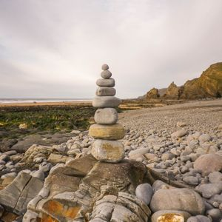 | KS1  - rock balancing  Can I make the tallest pebble tower in my class with a friend collecting 10 pebbles suitable for the task? Stipulate pebbles can only be their hand size for safety and that we do not throw stones.  - Can I skim a stone?  - Can I dam a stream?  - Can I identify different fossils?  - Can I build a paddling pool? | KS2  - rock balancing  Can I collect 10 pebbles with my partner?  After collection:  Can I build the tallest tower with the pebbles I have collected?  This adds a level of difficulty. Stipulate pebbles can only be their hand size for safety and that we do not throw stones. Children get to try a second time but this time they know the purpose and can select stones wisely.  - Can I skim a stone  - Can I build a driftwood raft?  - Can I build a shelter?  - Can I make a sand arch/tunnel to reach a partners hand the other side?
- Shadow faces  Can I make shadow faces with a partner? Mark making in the sand to show emotions.  Happy, sad, angry, excited.  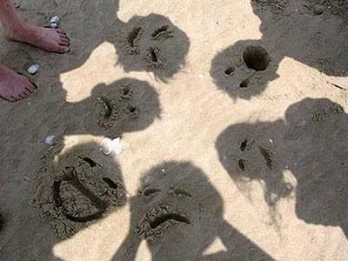 | - Shadow faces  Can I make shadow faces with a partner? Mark making in the sand to show emotions.  Happy, sad, angry, excited, embarrassed, nervous.  - Can I record the sounds of the sea?  - Can I take photographs of the sea? | - Shadow faces  Can I make shadow faces with a partner? Mark making in the sand to show emotions.  Happy, sad, angry, excited, embarrassed, nervous, jealous and confused.  - Can I take photographs of the sea?
- Mark making  Can I write my name in the sand?  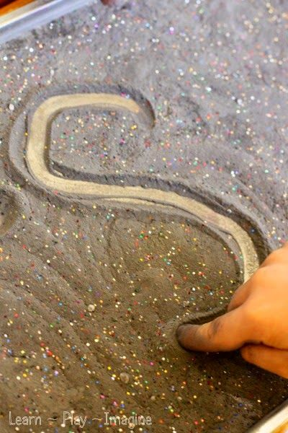 | - Mark making  Can I find beach objects and label them in the sand? | - Mark making  Can I write meaningful messages in the sand to correspond to the environment? Beach safety, Looking after the beach and creatures etc.  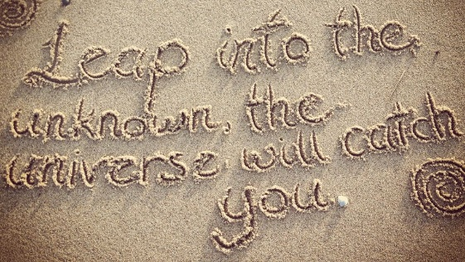
- Can I make patterns in the sand with a stick or other object? | - Can I make a collage self-portrait in the sand? | - Can I make a collage picture in the sand of the beach scene?
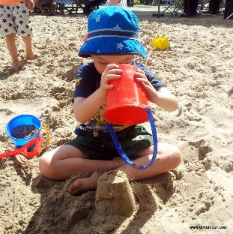  - Can I decorate a sandcastle? | - Can I build a sandcastle with moat?  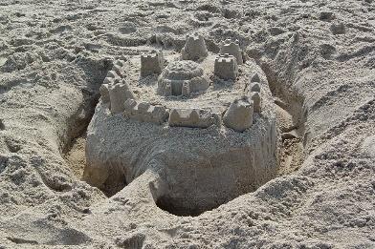 | 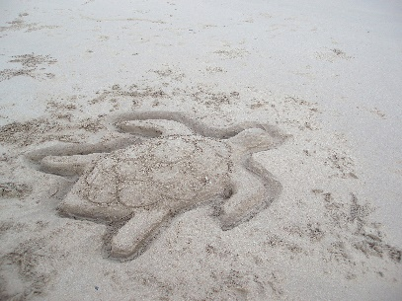  - Can I make a sand sculpture of a sea creature?
- Mathematics with pebbles  - Can I make a long line of pebbles and write the number on each pebble when counting them?  - Can I collect 10 pebbles?  - Can I make number bonds to the number shouted out by the adult? (Children can make 2 piles of stones to represent addition-model first)  - Can I collect 12 pebbles with my partner and write the numbers 1-12 on each pebble. Can I then arrange to make an analogue clock?  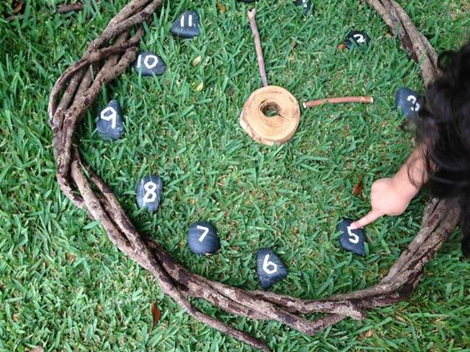 | - Mathematics with pebbles  - Can I collect 10 pebbles with my partner and write any number between 1-20 on each of the pebbles?  - Can I order my numbered pebbles from least value to greatest value?  - Can I make the number called out by the adult using any combination of numbers and any operation?  - Can I collect 12 pebbles with my partner and write the numbers 1-12 on each pebble. Can I then arrange to make an analogue clock? In groups of 3 can we make an o’clock, half past, quarter to or quarter past time called out by the third person? | - Mathematics with pebbles  - Can I collect 10 pebbles with my partner and write any number between 1-50 on each of the pebbles?  - Can I order my numbered pebbles from least value to greatest value?  - Can I make th number called out by the adult using any combination of numbers and any operation?  - Can I collect 12 pebbles with my partner and write the numbers 1-12 on each pebble. Can I then arrange to make an analogue clock? In groups of 3 can we make the time to every 5 minutes called out by the third person?

- Beach story time and songs  - Beach story sacks from beachcombing  Sharing a shell by Julia Donaldson  Sally and the Limpet by Simon James  The Snail and the Whale by Julia Donaldson  The Rainbow fish by Marcus Pfister  The Sea Poem  1,2,3,4,5 once I caught a fish alive  Row, row, row your boat  The waves in the sea go up and down, up and down | - Beach story time  - Beach story sacks from beachcombing  The Lighthouse Keeper’s Lunch  Tiddler by Julia Donaldson  Tom and Lucy at the Seaside by Shirley Hughes  Commotion in the Ocean by Giles Andreae  The Fish who could wish by John Bush | - Beach story time  - Plant lots of fir cones on the beach-story telling how did they get there?  The Lighthouse by Marjorie Wilson  Robinson Crusoe by Daniel Defoe  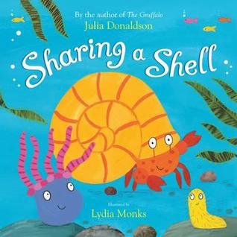

- Rock pooling and exploration  - Can I identify living things from a simple picture identification chart?  - Can I gently touch a crab held by an adult?  - Can I beachcomb for interesting things and sort into groups? by colour, by size etc.  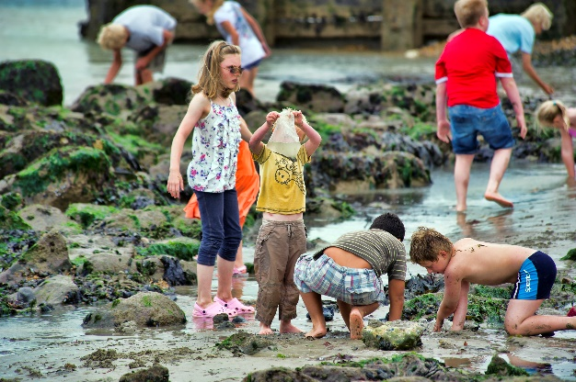 | - Rock pooling and exploration  - Can I identify living things from a more detailed identification chart with wider picture examples of seaweed and crab types?  - Can I stroke a crab or hug one gently as shown by VS?  - Can I beachcomb for interesting things and make a collage picture of a sea creature for others to guess at the end what it is? (extends everyone’s imagination) | - Rock pooling and exploration  - Can I identify living things using classifying charts and more information given to help identify with pictures and text?  - Investigate depth of pools and temperature at the deepest points and what can be found there.  - Can I stroke/hug or hold a crab gently as shown by VS?  - Can I beachcomb for interesting things and make a collage picture of a sea creature for others to guess at the end what it is? (extends everyone’s imagination)

- Beach games  - Can I throw a Frisbee?  - fishy, fishy, sharky, sharky  shallow area on grid at each end (narrow areas) shark has to catch fish before they reach the other side if caught other children become sea kelp which can reach out and catch other children but talk about foothold they can’t move as they’re anchored. (smaller grid)  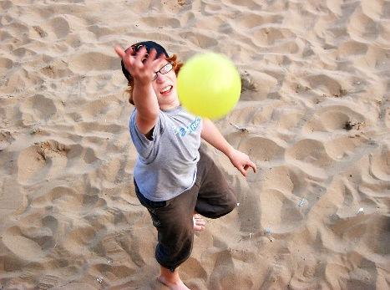 | - Beach games  - Can I throw and catch a beach ball?  - Noughts and crosses with 2 different coloured stone collections  - fishy, fishy, sharky, sharky  shallow area on grid at each end (narrow areas) shark has to catch fish before they reach the other side if caught other children become sea kelp which can reach out and catch other children but talk about foothold they can’t move as they’re anchored. (medium grid) | - Beach games  - Can I play beach rounder’s?  - Shark blindfolded in the middle with a pile of cones, other children have to creep not run to the shark without getting hit by a cone and touch the shark gently on the shoulder.  - fishy, fishy, sharky, sharky  shallow area on grid at each end (narrow areas) shark has to catch fish before they reach the other side if caught other children become sea kelp which can reach out and catch other children but talk about foothold they can’t move as they’re anchored. (larger grid)

- Beach food  - Have a beach picnic  - Eat an ice-lolly/ice-cream | - Beach food  - Make hot chocolate/lemonade  - Can you eat seaweed?  - Can make a pizza with a trangia?  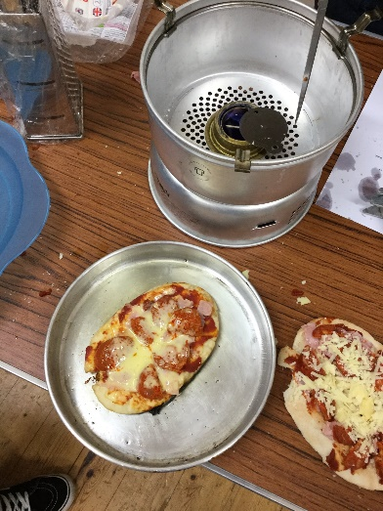 | - Beach food  - Toast marshmallows and make s’mores  - Can you light a fire and keep it going with beach resources?  - Can you eat seaweed?  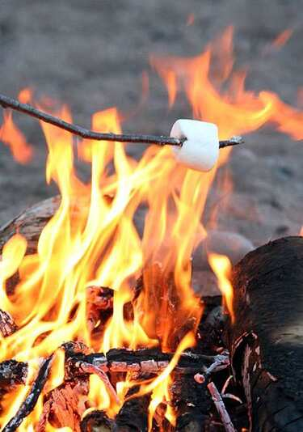  - Can you take the salt out of the sea?

- Safety and Care  - Can I meet a lifeguard?  - Can I paddle in a sandy rock pool?  - Can I paddle in the sea?  - Can I race a wave?  - Can I spot the lifeguard hut and safety flags?  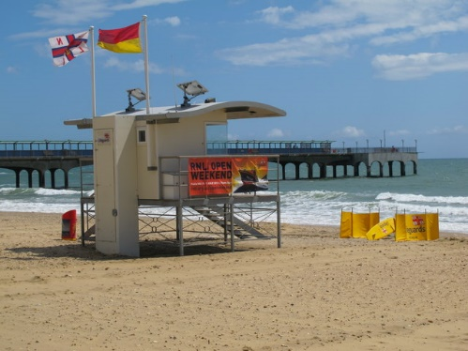  - Can I collect my own rubbish off the beach? | - Safety and Care  - Can I meet a lifeguard?  - Can I jump over the waves?  - Can I sit in the sea?  - Can I spot the lifeguard hut and safety flags?  - Can I collect my own rubbish off the beach?  - Can I make beach safety flag collages using coloured stones, seaweeds and shells?  - Can I play a game to help me remember the meaning of the flags? Adult shouts out meaning children run to that flag? | - Safety and Care  - Hit the surf  - Swim in the sea/bodyboarding/surfing  - Can I paddle up to the top of my legs?  - Can I collect litter from the beach following the safety rules?  - Can I identify different types of common litter found in our local area?  - Can I write meaningful messages in the sand to correspond to the environment? Beach safety, looking after the beach and creatures etc.  - Understand the tides and tide times.

