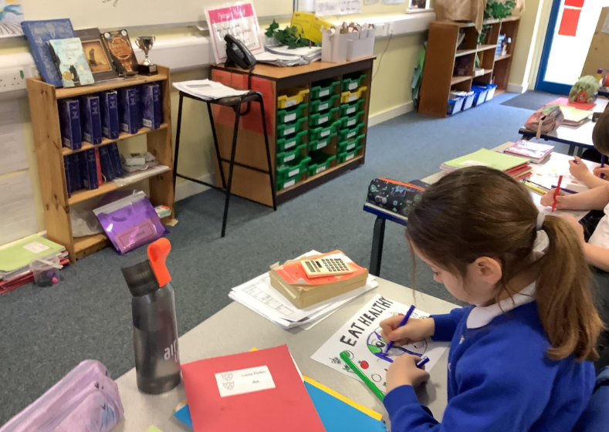

**‘Be Healthy’ in School Council- PSHE topic for Spring 2. 22.2.24 and 29.2.24 minutes..**

**We discussed our new topic and all of the things we do to promote health and wellbeing at Cayton School, such as a wide range of sports clubs for different year groups, athletic competitions, inviting visitors in for sports, healthy snacks -‘fruit only’ breaktimes- and we made posters encouraging the benefits of eating healthy. We discussed the food groups such as protein, vitamins and minerals which links with our Science curriculum as does the importance of exercise and a warm-up beforehand. Some members also mentioned that we might grow our own vegetables in the planters that Mrs Draper’s dad made for school. (I will ask him!) ☺**

