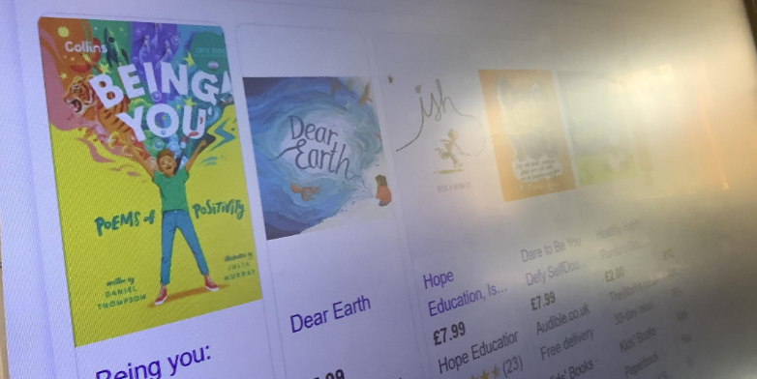
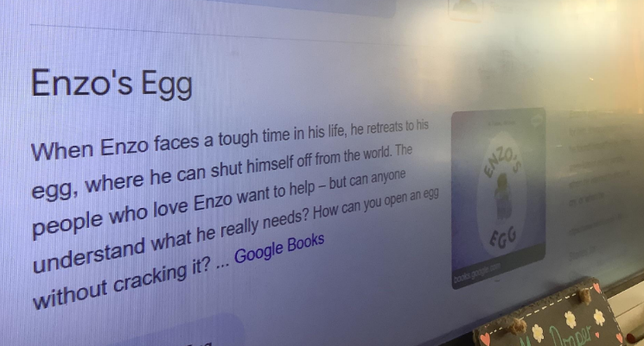
Relationships, Jigsaw PSHE, Minutes for School Council- 15.4.24
As part of school council, we discussed mental health, self-esteem, worries, online safety, the buddy stops and how this affects us and member of our school. We voted on EYFS, KS1 and KS2 books e.g. Enzo and the Egg after reading the blurbs and deciding which would be best for our school- we knew Mrs Wood would appreciate these links to Jigsaw also! We then watched a video about mental health and wellbeing which included tips for how to boost our own happiness and how to avoid negative thoughts. We then shared ideas for how to promote positive mental health throughout school. These included-

-Writing worries down.
-Worry boxes and class discussions.
-Audiobooks with mental health

