
Self-Harm Policy

Self-Harm Policy | Cayton School
Document Status | Adopted SIC Committee January 2026
Date of next review | January 2027 | Responsibility: Headteacher  SIC Committee
Success Criteria for review completion | Reviewed in line with NYC | Responsibility: Headteacher
Date of Policy Creation | January 2026 | Responsibility: Headteacher
Date of Policy Adoption by Governing Body | 21st January 2026
Method of Communication  (e.g. Website, etc.) | Shared Server/ email

- Introduction and Context

  - Recent research indicates that up to one in ten young people in the UK engage in self-harming behaviours, and that this figure is higher amongst specific populations, including young people with special educational needs. School staff can play an important role in preventing self-harm, building resilience and supporting pupils, peers and parents of pupils currently engaging in self-harm.

- Purpose

  - This document is a policy for staff working in this school who may be supporting pupils who self-harm.

- Aims

  - To adhere to the NYCC Self-Harm Guidance protocol.

  - To develop outstanding practice within this school to help and support pupils who self-harm.

- Definition of Self-Harm

  - Self-harm is any behaviour where the intent is to deliberately cause harm to one’s own body.

- Roles and responsibilities

The Governing Body

  - The governing body has the legal duty to safeguard and promote the welfare of their pupils. There may be a nominated governor who has responsibility for safeguarding who will have an oversight for provision for pupils who self-harm.

The Headteacher

  - The Headteacher has responsibility for establishing effective safeguarding procedures with regard to self-harm, thereby ensuring the duty of care of pupils and staff.

Staff

  - Pupils may choose to confide in any member of school staff if they are concerned about their own welfare, or that of a peer.

Referral procedures are:

North Yorkshire Local Safeguarding Procedures
- What staff must do if they are concerned about a child

All staff and volunteers working within North Yorkshire schools should follow the NYSCP Child Protection Procedures and Practice Guidance which is consistent with Keeping Children Safe in Education; Working Together to Safeguard Children 2023 and What To Do If You Are Worried A Child is Being Abused 2015.
For guidance regarding how to make a referral to the Children and Families Service in North Yorkshire please visit: NYSCP (safeguardingchildren.co.uk)

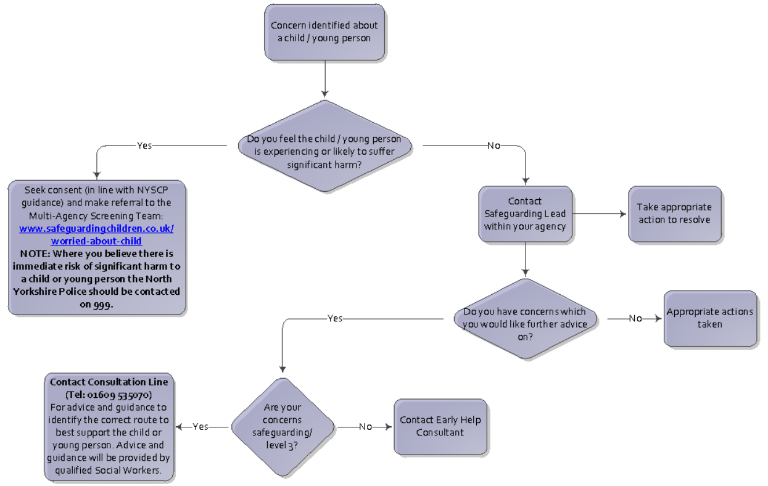

Staff must immediately report:
- Any suspicion that a child is injured, marked, or bruised in a way which is not readily attributable to the normal knocks or scrapes received in play;
- Any explanation given which appears inconsistent or suspicious;
- Any behaviours which give rise to suspicions that a child may have suffered harm (e.g., significant changes in behaviour, worrying drawings or play);
- Any concerns that a child may be suffering from inadequate care, ill treatment, or emotional maltreatment;
- Any concerns that a child is presenting signs or symptoms of abuse, neglect or exploitation;
- Any significant changes in a child’s presentation, including non-attendance;
- Any hint or disclosure of abuse, neglect or exploitation received from the child, or from any other person, including disclosures of abuse, neglect or exploitation perpetrated by adults outside of the family or by other children or young people;
- Any concerns regarding person(s) who may pose a risk to children (e.g., staff in school or person living in a household with children present) including inappropriate behaviour e.g., inappropriate sexual comments; excessive one-to-one attention beyond the requirements of their usual role and responsibilities; or inappropriate sharing of images;
- Any concerns related to exploitation and serious crime, including knife crime;
- Any concerns relating to child-on-child abuse;
- Any concerns relating to youth produced sexual imagery (sexting); and
- Any concerns relating to a child’s engagement with extremist groups or ideologies.

  - This includes all staff being aware of the North Yorkshire pathway of support for children and young people who deliberately self-harm.

- Training

  - Schools are recommended to access training regularly on self-harm. Staff giving support to pupils who self-harm may experience all sorts of reactions to this behaviour in pupils (e.g. anger, helplessness, rejection); it is helpful for staff to have an opportunity to talk this through with work colleagues or senior management.

  - Staff taking this role should take the opportunity to attend training days on self-harm or obtain relevant literature. Induction procedures for all staff, outlined below, will include training on Self-Harm, Child Protection procedures and setting boundaries around Confidentiality.

- Meeting with Mrs Wood (DSL) to complete training. On-line training from the key.

- Monitoring and Evaluation

  - The designated governor who has responsibility for safeguarding will monitor the systems yearly and following any incident of self-harm.

  - Policy reviewed on:

9th January 2026

By:

Mrs Juliet Monaghan

