Attendance and Persistent Absence Data Story 2019-2024

IDSR (Inspection Data Summary Report) information that shows our school story over the last 3 years.
5 years ago, our school attendance and our school persistent absence levels were unfortunately within the highest 20% of schools across the country. Meaning we had improvements to make in both areas. See IDSR Data below

IDSR Historical Data:
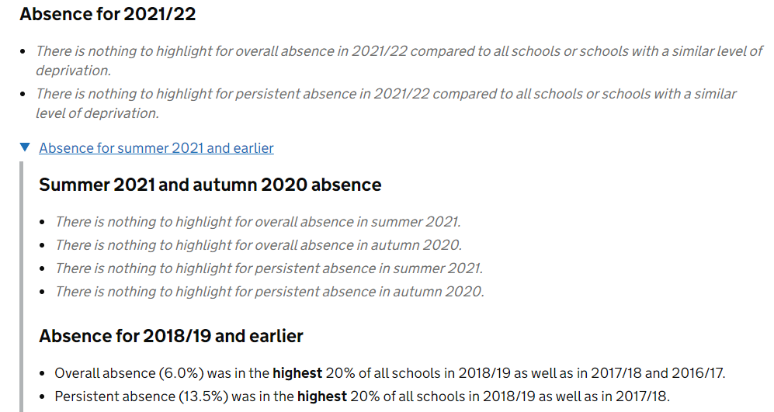

However, with support from leaders and consistent improvements to the school curriculum. Added to the understanding and support from parents/carers, we are now able to tell parents that in our latest IDSR, our figures have flipped and are in the lowest 20% of all schools for attendance and persistent absence. Which is something to be really proud of.
Please see the latest IDSR Attendance Data:

