**26.2.25 Minutes**

**In the session, we reminded class teachers about the reasons behind the kindness box and encouraged teachers and school council members to promote acts of positivity e.g. helping a buddy in lessons as reasons for being in the kindness boxes. We discussed new ideas including eco posters and promoting helping the environment. ☺**

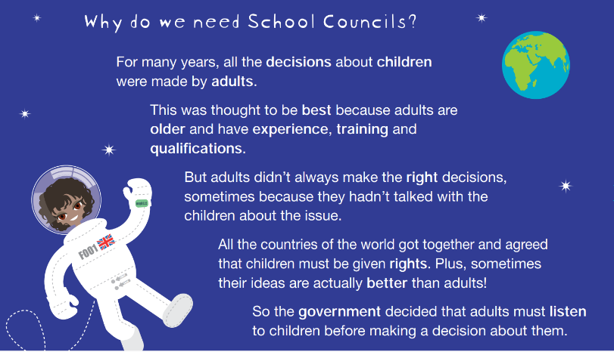**Mrs Draper gave out the new certificates for kindness during her assembly and this gave children a new incentive for their actions. More books about kindness and acceptance (British Values and diversity) were then put in the library by school council who promoted these in their classes and during Reading Buddies also!**